Time Tracking

General Steps for Logging Time (Project Related)
- Navigate to the appropriate work item in Jira.
- Click on the ellipses as per the screen shot below, and click on Log Work.
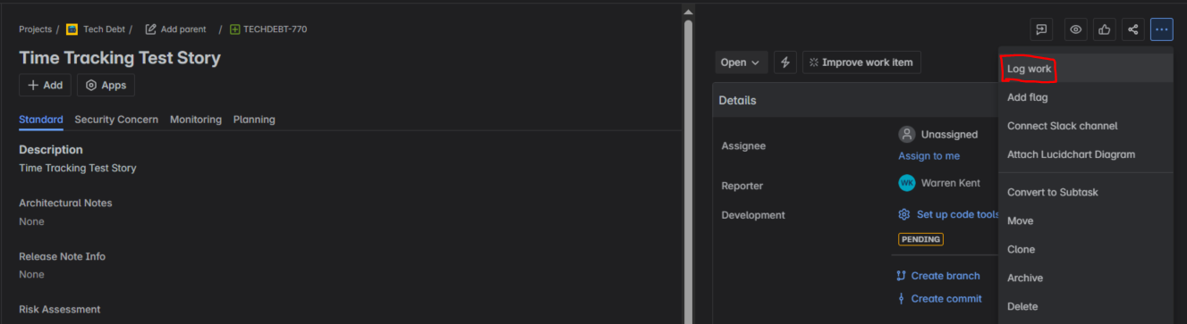
- Enter the Time spent (e.g., 1h, 30m, 2h 30m etc.), Time remaining (optional), date started (exact time is not important) and add a concise summary of the task performed under the Work description field.
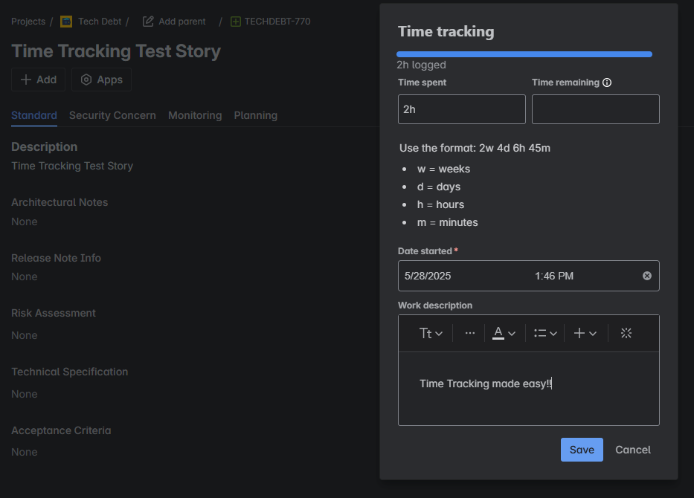
- Click save.

General Steps for logging "Unallocated" time (non-project related)

- Each agile release train (ART) will have a ticket for “Unallocated Time Tracking”.
See below example for VisionAI)
- Each Unallocated Time Tracking ticket will have 3 sub tasks, namely:
  - Leave / Vacation
  - Sick Leave
  - Administration
- Use these to log work-related activities not directly tied to a planned project deliverable.
  - Examples:
    - General meetings or stand-ups. (Administration)
    - Professional development or training (Administration)
    - Miscellaneous administrative tasks (Administration)
    - Team building activities. (Administration)
    - PTO (Leave / Vacation)
    - Sick leave. (Sick Leave)
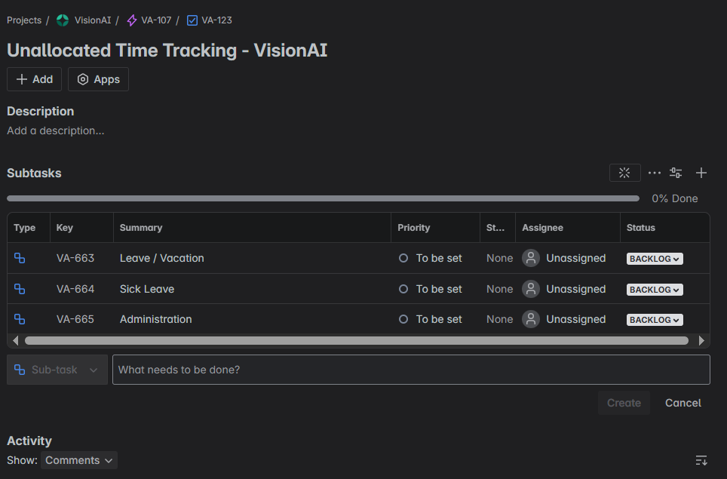
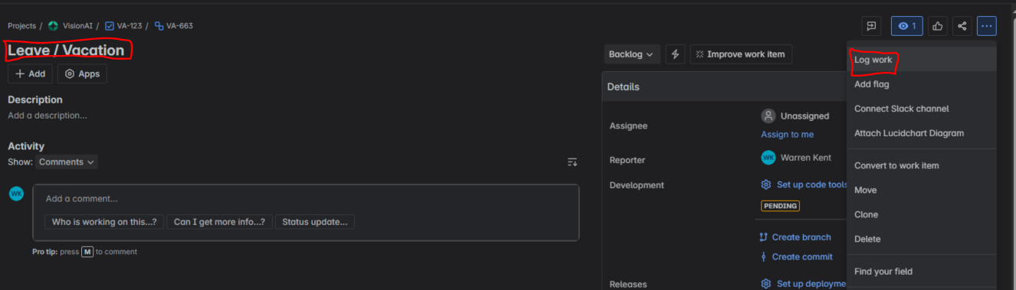
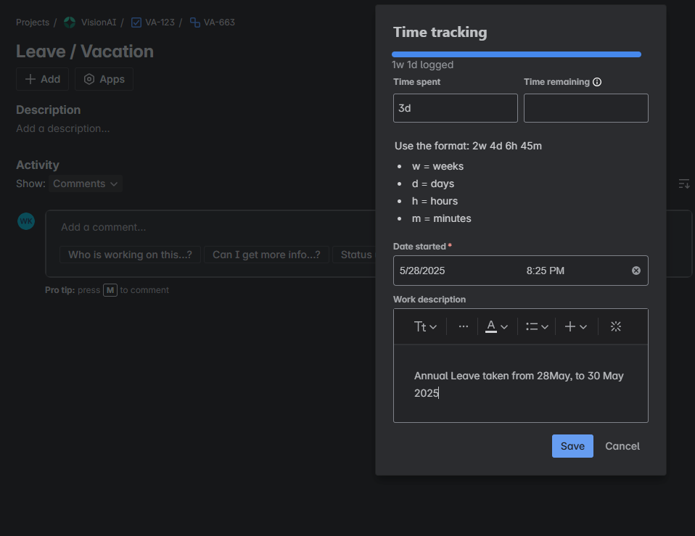
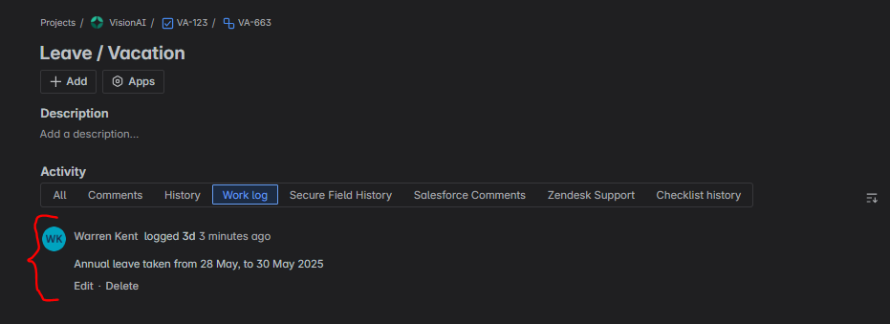

Key Reminders
- Logging time daily improves accuracy and prevents having to back track on what work was done in the past.
- Include descriptive comments to provide crucial context.
- Ensure you log time against the correct work item.
- If you don't know where to log a specific activity, ask your Scrum Master or Team Lead.

